PHI Patterns and Mineral Occurrences

- Summary
PHI patterns are geological tectonic sets combining circular shaped fault segments with crossing shear zones, which happen to appear often close to mineral occurrences.
A first paper, companion to this one, looked at the way to locate them in a reproducible fashion across the SRTM database with the assistance of various methods: Hough or Radon transforms and the deep convolutional neural networks.
This paper lists and discuss a verified set of occurrences on the basis of their geology and their economic potential.
In several cases, the occurrences appears right on the rim or in the shear zone within the rim.
The occurrences grade shells indicate often that their mechanical constraints are coherent with the PHI pattern.
The PHIs belong to a continuum that spans over meteorite impacts, alkaline ring complexes, intrusive stocks and calderas. The large impact structures also generate a rise of magmas and some of the deep PHI structures might result from either causes. They can be detected preferentially in old terranes or their immediate cover formations.
Although they are not detected with each and every mineral deposit, their presence is usually a guide that should be questionned.

1.1. Introduction

PHI (Φ) patterns are interpreted tectonic sets showing a combination of ring and linear elements crossing each other, the circular element size may range between a few km for the smallest and a few hundred km for the largest. The width of the lineaments range from a few hundred meters to tens of kilometers.
Their spatial correlation with mineral occurrences is intriguing: many among the Φ patterns cover or are tangent to deposits of iron, gold, copper, zinc, diamonds, rare earth or uranium.
PHI patterns are addressed abundantly in Russian literature since at least five decades, they were introduced in western literature by O'Driscoll (1985) and Kutina (1995) ; most references are available only in Russian (Bryukhanov 1987, Florinsky 2006, Gavrilov 2012).
Several authors have tested the predictive capacity in establishing the vicinity of deposits with prospectivity patterns drafted on the basis of PHI structures, their results are puzzling, if not impressive (Bubner 2008, Gavrilov 2012, Witschard 1984, Eggers 1979, Saul 1978).

Ring structures cover a wide range of geological events, from calderas via the alkaline ring complexes, intrusives of various kinds including kimberlites, mud volcanoes, meteorites impacts and more exotic features.
Those features whose magmatic filiation is simple and obvious are not reviewed here, for instance the alkaline rings as Tamgak in the Aïr region of Niger, the well identified volcanic calderas or the known meteorite impacts.
The patterns targeted by this study have typically a radius between 10 and 100 km. They can be spotted by direct visual observation of DEMs or satellite images but they have “stealth” qualities and with a bit of eye fatigue you finish seeing them nowhere or, alternatively, everywhere.
That is why the first part of the research was to find reproductible ways of identification using circular Hough and Radon transforms plus a trained dense convolutional neural network.

.
1. Origin and metallogeny of PHI (Φ) patterns

1.1. Rationale
Characteristics of 41 structures which were verified according to the methods described in the first paper are summarized in Table I.
All examples share a tectonic signatures translating vertical movements. Ultimately these movements could be produced either by a meteoritic impact or by a gravity collapse consequent either to gases or magmas emission.
The following questions should be addressed:
- How does the Φ pattern originate and how do the circular and linear elements succeed respectively in time?
- Is there a clear spatial, temporal and genetic link to specific mineral deposits?
A practical application is emergent below these two questions: does the search for Φ pattern increases the chances of finding new mineral deposits, or improving knowledge of old mining districts?
Columns 13-15 of Table I address the relationships between the structures and the mineral occurrences: timing, structural position, mechanical inference of the circular and linear structure with the orebodies.
1.1. Circular Features
Three possible origins are discussed for the PHI structures:
- meteorite impact,
- magmatism,
- other origin not linked directly to magmas or volcanoes.
1.1.1 Impact origin
The general outlook, between larger impacts and annular magmatic complexes, suggests that the overall effect might be similar in depth. The largest meteorites described in the literature, always trigger a raise of magmas. The role of impacts in degassing the earth has been advocated by Gilat et al 2005, 2012. A substantial quantity of fluids is latent in the mantle and impact could have a thixotropic effect, focusing fluids upwards towards the shock core area and initiate a plume.
At Vredefort, one of the largest impact studied, the initial shock was dated at 2023+-4 Ma. After that “anatectic granites” raised and metamorphism developed, giving dates at 2017 +- 5 Ma ( Reimold 2015).
Apart from Vredefort and a few other examples listed by Grieves (1994) and Reimold (2005), it is extremely difficult to prove a meteoritic impact origin for old and deeply eroded features. Most examples of table I are very old, the would-be surface crater had all chances to be largely eroded and the shatter cones were washed out.
Reimold et al (2015) have reviewed meteorite impacts over Africa. They list 19 “confirmed” examples and 49 “proposed” ones. The list given in table I share only Vredefort, over the Rand Conglomerate in South Africa. Most of impacts in Reimold (2015) list are relatively young and well preserved; their scale is small at less than 5 km radius and with no real connection to a mineral deposit.

TABLE I PHI STRUCTURES LOCATIONS
Name | Country | Commodity | Northing | Easting | Radius km | Northing | Easting | airborne az | gradiometry az | Sat Im az | Timing | Position | Mechanics | Shear | REF
Argyle | Australia | Diamond | 16°41'S | 128°22'E | 16 | 16°46'N | 128°15'E |  | 79 | 78 | S | R
Arizona | USA | U+ Polymetal | 34°14N | 111°08W | 34 | 33°58'N | 11°22'W |  | 50 |  |  | P
Bakouma | CAR | U | 05°41'N | 023°44'E | 44 | 5°47'N | 22°45'E |  | 79 |  | P | P | T | NE/SW | Uramin 2007
Bisie | DRC | Sn | 01°06'S | 027°36'E | 19 | 0°59'S | 27°34'E |  | 65 |  | S | P | T | EW | Alphamin website
Boddington | Australia | Au | 32°52'S | 116°17'E | 30 | 32°56'S | 116°34'E |  | 51 | 52 |  | C | S | ENE
Bombore | Mali | Au | 12°13'N | 000°42'W | 35 | 12°02'N | 0°56'W |  | 79 |  | E | R |  | ENE
Boninkro | Ivory Coast | Au | 06°20'N | 005°03'W | 13 | 5°43'N | 4°02'W |  | 73 |  | E | P | T | ENE | Endeavour 2014
Bron Afafo | Ghana | Au | 07°13N | 002°10W | 11 | 7°11'N | 2°15'W | 83 | 76 | 83 |  | C |  | ENE | Newmont website
Dima Kolwezi | DRC | Cu, CO | 10°41'S | 025°11'E |  | 10°33'S | 24°54'E |  | 75 | 85 | P | C | H | ENE | IvanPlats 43-101
Evander/Reitz | RSA | Au | 27°53'S | 028°56'E | 28 | 27°59'S | 28°41'E |  | 49 |  | P | P | H | ENE
Nabesna | USA | Au | 62°10'N | 144°11'W | 61 | 61°45'N | 144°49'W |  | 78 | 80 | S | P |  | NW | USGS 2000
Freda Rebecca | Zimbabwe | Au | 17°00'S | 031°29'E | 30 | 17°06'S | 72°14'E |  | 72 | 75 |  | R
Geita | Tanzania | Au | 03°30'S | 031°51'E | 31 | 4°00'S | 80°04'W |  | 80 | 80 | P | P
Kalana | Mali | Au | 10°34'N | 007°17'W | 22 | 10°22'N | 7°20'E | 76 | 75 | 73 |  | P | T | ENE | Avnal 2014
Kalgoorlie | Australia | Au | 30°37'S | 121°00E | 49 | 30°42'S | 121°28'E |  | 101 |  |  | P | T | SSE | Philips 1986
Katako Kombe | DRC | Diamond | 03°37'S | 024°31'E | 19 | 3°32'S | 24°22'E |  | 83 | 84
Kiaka | Burkina | Au | 11°41'N | 000°57'W | 21 | 11°32'N | 1°05'W | 78 | 51 |  |  | R | V | NE
Komana | Mali | Au | 11°22'N | 009°05'W | 6 | 11°21'N | 9°17'W | 60 | 62 | 60 |  | P R | T | ENE | Glencar 2007
Kouroussa | Guinea | Au | 10°33'N | 009°49'W | 11 | 10°26'N | 9°49'W |  | 60 |  |  | P | V | ENE | Cassidy
lawn hill | Australia | Zn | 18°25'S | 138°51'E | 45 | 18°16'S | 138°31E |  | 77 | 77 | P | P | Z | SH | Broadbent 1999
Lero | Guinea | Au | 11°42'N | 010°07W | 7 | 11°46'N | 10°06'W |  | 92 | 87 |  | P | R | S4 | Crew Gold
Loulo | Mali | Au | 13°13'N | 011°13'W | 23 | 13°05'N | 11°23'W |  | 79 | 61 |  |  | P |  | Randgold
Mana | Burkina | Au | 11°51'N | 003°28'W | 13 | 11°45'N | 3°53'W | 70 | 130 (70) |  |  | R |  | ENE | Semafo 2013
Massawa | Senegal | Au | 12°51'N | 011°43'W |  | 13°03'N | 11°25'W | 65 | 61 |  |  | P | T | ENE | Randgold 2015
Morila | Mali | Au | 11°46'N | 006°44'W | 29 | 11°38'N | 6°57'W |  | 79 | 75
Muruntau | Ouzbekistan | Au | 41°29'N | 064°28E | 51 | 41°29'N | 64°50'E |  | 92/124 | 130 | S | C |  | NE | de Boorder 2015
Nampala | Mali | Au | 11°01'N | 006°06W | 17 | 11°06'N | 6°27'W |  | 61 | 68 |  | P | T | NNE | Robex 2011
Popigai | Russia | Diamond | 71°33'E | 110°50' | 33 | 71°20'N | 110°12E |  | 58 |  |  | S
Poura | Burkina | Au | 11°25'N | 012°03W | 43 | 11°47'N | 2°9'W | 66 | 87 |  |  | P | T | ENE
Pueblo Viejo | Honduras | Au | 18°59'N | 070°11'W | 21 | 18°50'N | 70°20'W |  | 91 |  | S | C |  |  | Goldcorp 2008
Puquios el Teniente | Chile | Cu | 33°55'S | 069°52'W | 34 | 34°12'S | 70°38E |  | 78 | 80 | S | P
Sabodala | Senegal | Au | 13°15'N | 012°18'W | 21 | 13°41' | 12°07' | 68 | 61 |  |  | P | T | ENE
Sadiola | Mali | Au | 13°38'N | 011°52'W | 34 | 13°404N | 12°10'W | 67 | 52/67 | 60 |  | P | T | NE
Samira Hill | Niger | Au | 13°27'N | 001°27'E | 18 | 13°28'N | 1°18'E | 71 | 78 |  |  | P | T |  | Etruscan 2005
Shalkar | Ouzbekistan | Au | 42°21'N | 063°23'E | 49 | 42°35' | 62°48' |  | 87 |  | S | C
Siguiri | Guinea | Au | 11°26'N | 009°27'W | 15 | 11°32'N | 9°26'W | 80 | 79 | 76 |  | C P | T | ENE | Steyn
Syama | Guinea | Au | 10°52'N | 006°01'W | 28 | 11°02'N | 6°19'W |  | 76 | 66 |  |  |  |  | Resolute 2012
Tahoua | Niger | Fe | 14°19'N | 005°59'E | 15 | 14°55'N | 5°52'E | 89 | 67 |  | P
Tasiast | Mauritania | Au | 20°43'N | 015°08'W | 44 | 20°29'N | 15°33'W |  | 57 |  |  | P | T |  | Kinross 2012
Tasmania | New Zealand | Cu | 40°58'S | 172°33'E | 25 | 40°47'S | 172°23'E |  | 70 | 65 |  |  |  |  | Eggers 1981
Vredefort | RSA | Au | 27°04'S | 027°25'E | 37 | 27°14'S | 27°08'E |  | 52 |  | P | R | S | NE | Reimold 2005

Columns 1 to 3: site name, country and associated commodity
Column 4 and 5: northings and eastings of the centers for the structures
Columns 7: radius of the circle
Columns 8 and 9: northings and eastings of one point from the crossing shear
Columns 10: crossing shear azimuth from magnetics
Column 11: crossing shear azimuth from the gravimetric gradiometry
Column 12: timing relation between the orebody and the structure: progenetic (P), syngenetic (S), epigenetic (E)
Column 13: position of the orebody versus the structure (P): periphery, on the rim, (C): central, (R) radial (i.e. within the circle)
Column 14: attitude of the orebody shell to verify mechanical coherence with structure: T: tangential (to cone), H sub horizontal, V vertical radial
Column 15: direction of mineralized shears
Columns 16: references

Reimold et al (2015) have reviewed meteorite impacts over Africa. They list 19 “confirmed” examples and 49 “proposed” ones. The list given in table I share only Vredefort, over the Rand Conglomerate in South Africa. Most of impacts in Reimold (2015) list are relatively young and well preserved; their scale is small at less than 5 km radius and with no real connection to a mineral deposit.
A list of +-280,000 meteorite stones discovery sites is given in a Google forum (Google 2015). The number of impact geometries verified is about 170 and the amount suspected about 600. The data over Africa was checked but most inferred impacts are small and a few large ones either do not have a plausible imprint or are not nearby to a known deposit. The vicinity to meteorite stones findings was not convincing enough to argument about it.
The metallogeny of the impact structures has been reviewed by Grieves et al (1994) and by Reimold (2005).
According to Grieves et al there are three types of deposits in relation to the impacts: progenetic (P), syngenetic (S) and epigenetic (E). In the case of Vredefort the deposit is progenetic with a tectonic influence (lifting up of the Rand formations) and a hydrothermal influence that re-mobilized and enriched many locations: gold mines distribution follows preferably the NE shear zones.
Giant to super-giant deposits like Vredefort, Olympic Dam, Broken Hill or Mount Isa (Laznicka 2006) are in the vicinity to circular mega structures identified as old impacts by several authors (O’Driscoll and Campbell, 1997, Saul 1978, Robinson 2005), although only Vredefort is confirmed as a true impact.

The impacts of large meteorites crushed the rocks down to a depth exceeding 6km; the breccias are expanded and lighter, which do translate generally into a negative gravity anomaly (French 1998). Based on observations of Klococknick et al (2010) one would expect to see are least half a ring of low density in the signature. On that basis from table I: Arizona (Mogollon), Dima, Tasiast and Kalgoorlie could be old impacts.
1.1.2 Genuine magmatic origin

Wall et al (2005) have developed an interesting “TAG: thermal aureole gold” model. Although not designed with PHI structures in the rear sight, it is inspiring as it outlines the concepts of center and circular periphery for targeting. Take notice that Muruntau circular structure is eight times larger than shown in their block model ( FIG 15).

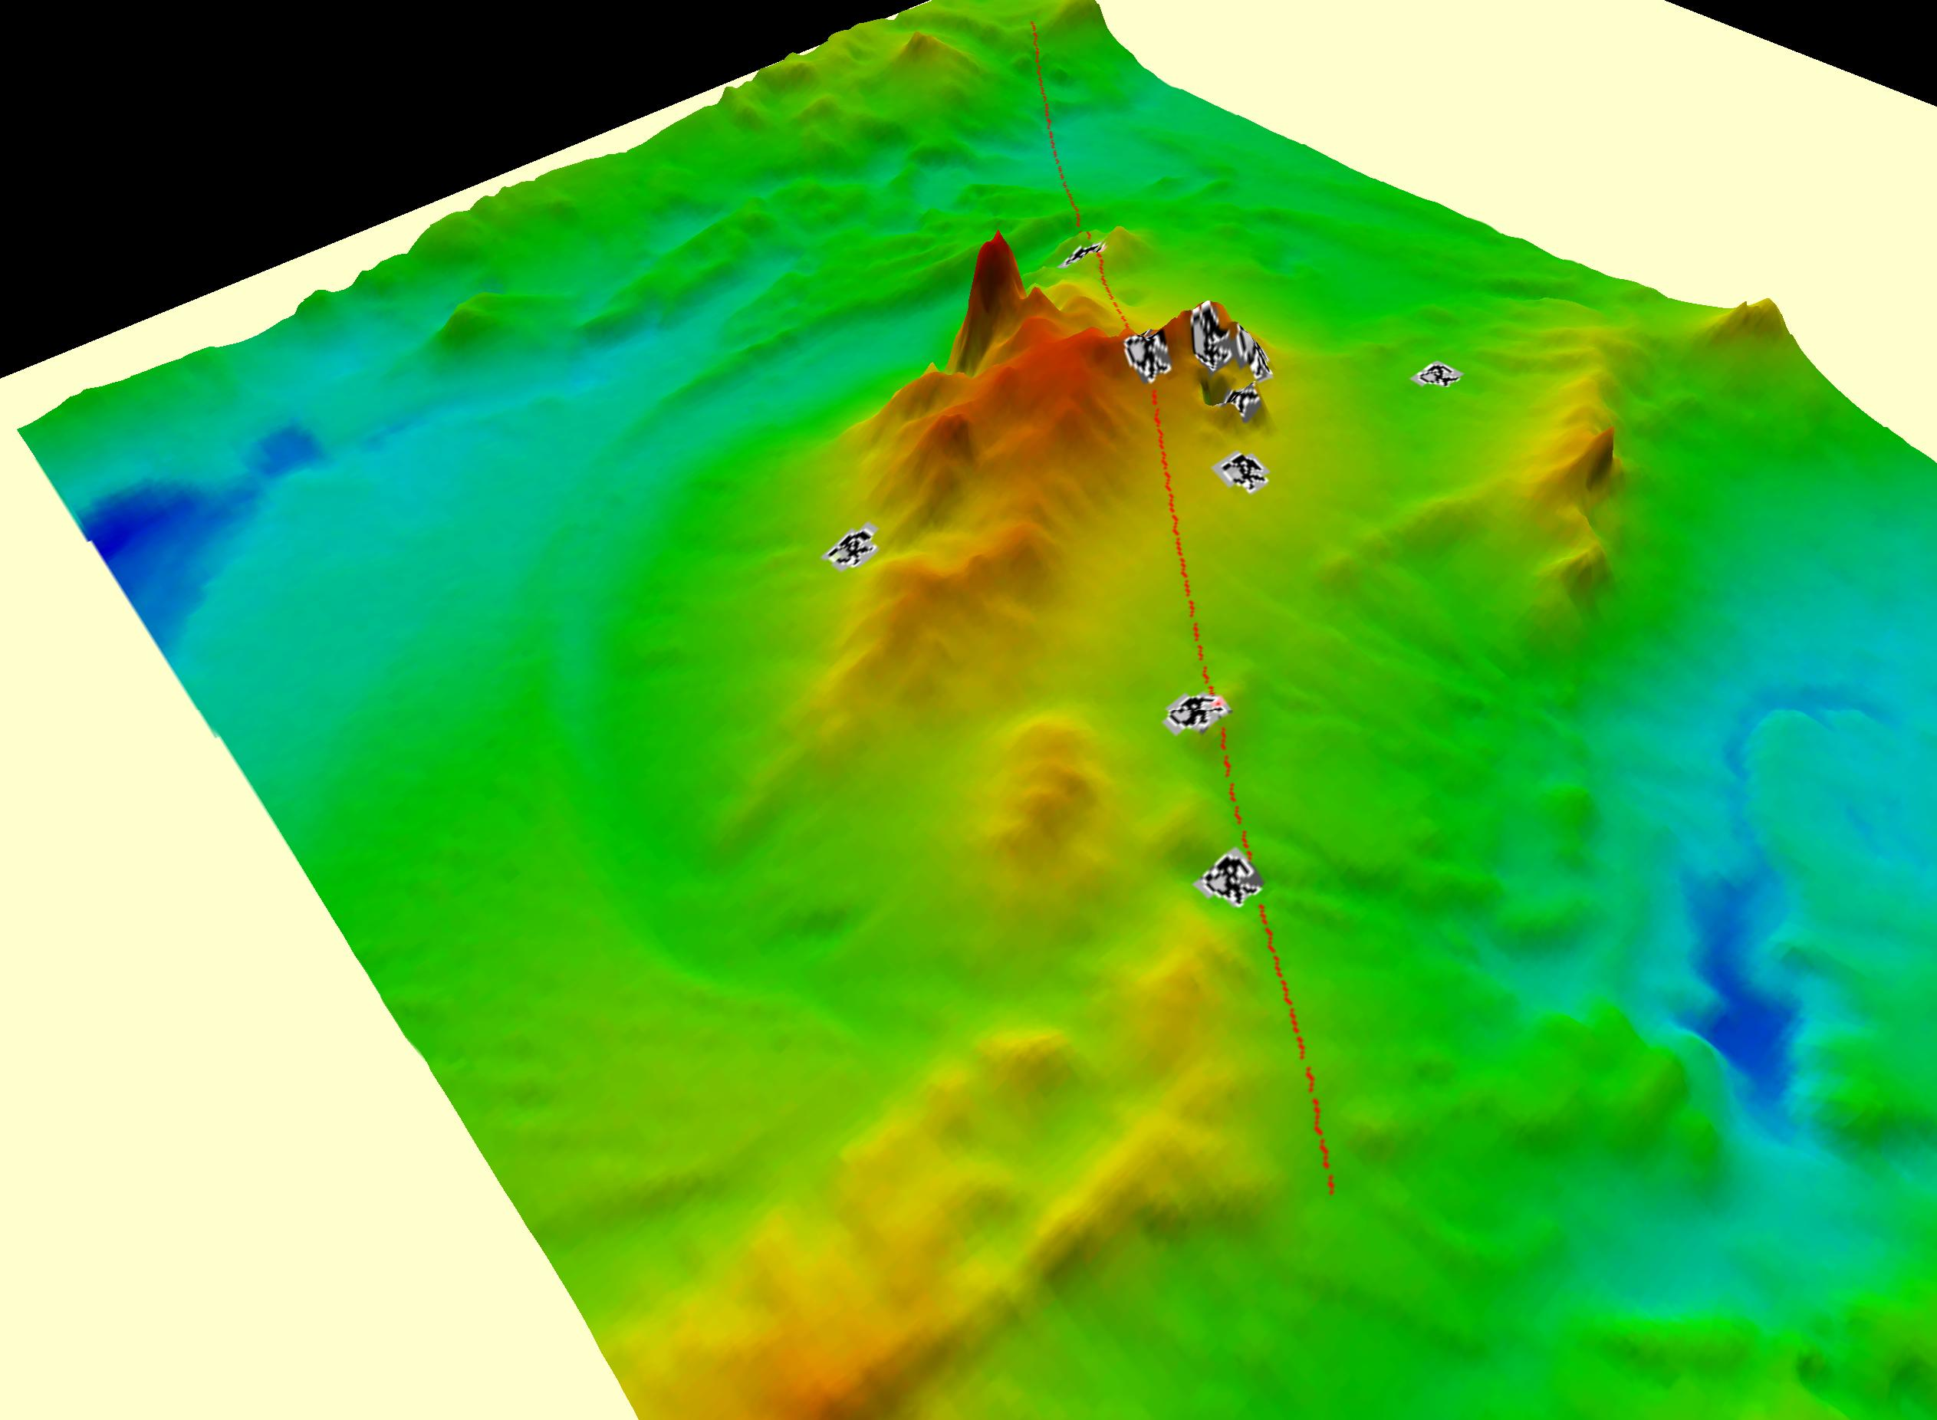 | 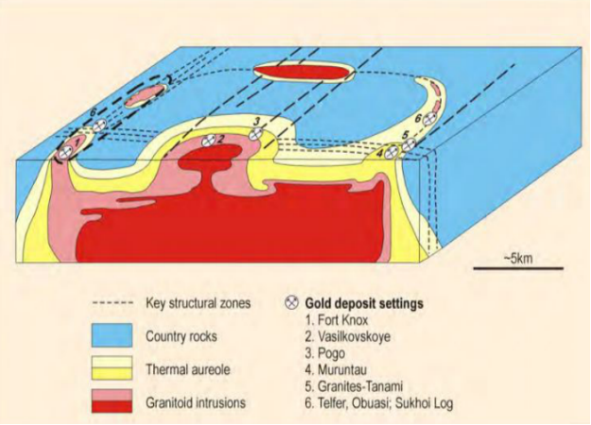
FIG 1 Muruntau, a typical PHI pattern. Left: view from SW: the TAG model from Wall 2005, right: the radius of Muruntau structure is about 40 km, the Muruntau open pit shows in dark over the hill, the other gold mines are shown with the mining symbol. Right: TAG model from Wall(2014).

The rosary of gold deposits along Muruntau (FIG 1 mining symbols, after Wall 2014) is a good example of how the crossing shear zone influences the mineralizing process, there is another EW SZ passing across Muruntau indicated by the gravimetric gradiometry.
Among the magma related occurrences in Table I are: Bisha (gabbro), Muruntau, Shalkar, Puquios, Pueblo Viejo
1.1.3 Structures without magmatic or volcanic indications
Most of the PHI occurrences listed in table 1 or those used in the neural network training do not give any indication of the presence of a significant intrusive or of a significant volcanic activity susceptible to generate calderas.
These Φ structures could appear at sites where the ground swell was initiated by a pocket of gases or fluids which escaped thereafter leaving scant traces of their passage, apart from the ring structure. Gilat (2005, 2012) indicates that tremendous gases activities are generally overlooked .

1.1.4 Link to the mineral occurrences and timeframe
While the TAG, copper porphyries models and kimberlites are syngenetic, the relationship is less obvious in other types of deposits.
The piston effect and the circular structures it created influences topography during long periods and probably for many of them, up to present.
In the case where the circular feature is expressed through a large sedimentary blanket overlapping strata-bound deposits like copper in DRC, gold in Vredefort, Uranium in Bakouma or iron in Tahoua, the superposition principle indicates clearly a progenetic case (P). Hydrothermalism, whatever its cause, combined with continued tectonic movements have improved the economic value of related occurrences:
- the PHI structure west of Kolwezi is covered by the NW thrust slice, however later circular cracks in the neighborhood penetrate the thrusted formations;
- the Vredefort structure was impacted before the Karoo deposition but circular faults have replayed and penetrated the Karoo cover ;
- In CAR the Bakouma U is linked to neoproterozoic sediments but circular fractures nearby cut across nappes of various ages.
- In Mali, near Sadiola some circular fractures stop at the escarpment of the infracambrian sandstones while several structures nearby are developed in the sandstones, idem on the Senegal side...

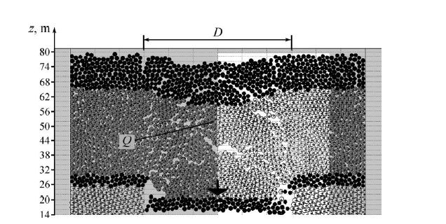
Grieves et al (1994) mention that orebodies favor a locations along the ring.
In table I the locations are referred as central (C), radial(R) or peripheric (P) when the orebody is right on the circle.

FIG 2 Sub-level casing models, applicable to the circular features (from Rusin et al 2007)

Rusin et Al (2007) have developed a tectonic model of circular structures based on the discrete element method (see FIG 2). Their model, which applies to sub-level caving in mines, outlines two concomitant morphologies: steep cracks along the circular structure and tabular, en echelon, within the perimeter. The collapse environment could explain why, in some copper, uranium or zinc provinces, steep and rich shoots coexist with stratabound lenses.
To confirm a mechanical kin, the mineralized bodies at the periphery should belong to cones sharing the axis of rotation of the structure, with limits tangent to the circle (T). Sub-horizontal flat bodies or lit-par-lit replacements (S) could be expected within the radius where steep bodies could have a radial attitude (V). The letters refer to Table I, where a mechanical coherence was checked.
Except for Vredefort there is no radiometric age collected for any of the structures listed in Table I.
The dolerites/lamprohyres sills described in many West African or Australian mines might well be linked with collapses and, if verified, could give a minimum age to the structures.

Several hundred mineral occurrences were reviewed in the frame of this study for establishing an eventual link to circular structures. Although the search was not exhaustive it appears that the association between circular features and a significant deposit is more frequent in the Archean or early Proterozoic terranes, or their immediate cover formations.

1.2. Linear Features

The cross-cutting principle is of little help in defining the relative position of the circular and linear features in time as both structures are continuously re-playing.
The observations on global scale magnetic and gravimetric maps suggest that linear features display spiral patterns, which translate torsional effects in the crust. This idea was first advocated by Rance (1967) and later illustrated by O'Driscoll (1980) and Florinsky (2006). Cheh Pan (2014) has reviewed the impact of the inertial torques on the globe.
Large shear zones have been studied in details by Vauchez et Al (1995, 2012); they are intimately linked to the mantle fabric which is anisotropic in most places. The anisotropies in the mantle are recorded in the preferred orientation of the olivines and translate with different seismic waves speeds (Bokelman et al 2009).
Along the global shear illustrated above FIGs 7 and 8, ages are recorded from very recent (it cuts across the Cameroon volcanoes line) to ancient ( Archean, “Leonian”,in West Africa and Proterozoic ,“Patos Campina Grande”/”Pernambucco” SZ, in Brazil, reactivated and probably older). This global shear is active, still today, in Ghana (Ghana 2015).
The remanence can be seen at the edge of the continents when the corridors connect to the ocean crust and adapt to the drift and rotation; as well it is likely that the very complex figures of the Borborema shear zones complex in Brazil may be due to a twist between the crust and the deep roots of the shear zone, in the mantle (Vauchez et al 1995).
At field scale, these shear zones are relatively inconspicuous, they are very wide and are mostly interpreted as a regional background; as a result their role is frequently overlooked.
Based on the superposition principle, it is likely that large linear features pre-date the local, round, structures.
The large shear zones can be identified on outcrops and thin sections, for instance the ENE shearing is well documented in West African mines as it clearly affects the distribution of gold.
For instance in the Obuasi mine the ENE direction duplexes (F4 see Allibone et al 2002, Perrouty 2012 ) create extensions filled with gold bearing quartz veins

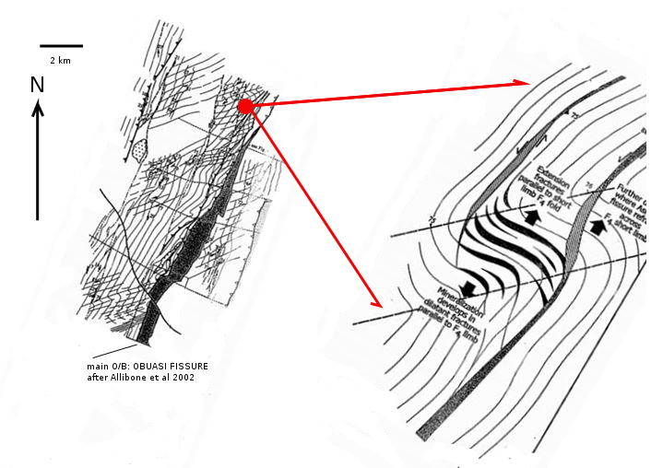

FIG 17 Influence of ENE shearing on Obuasi mineralization (after Allibone 2002).
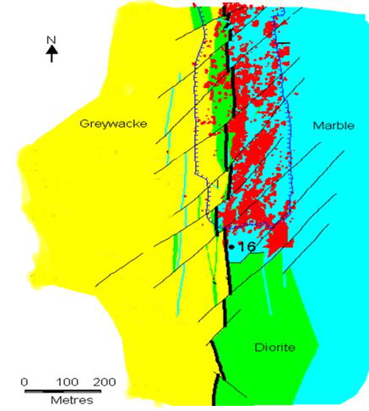
FIG 18 Influence of NE shearing on Sadiola mineralization (Riedels) sees directions in FIG 12 for comparison (after AngloAmerican).

The last column in table I indicates the direction of influence of the linear feature.

2. Synthesis

Based on geology and the large scale geophysical signatures, the family of PHI structures does not look homogeneous but overlaps impacts, intrusive stocks and calderas.
The question of a possible impact cause remains undemonstrated for all the examples of Table I except Vredefort.
Laznica (2006) commented “The idea that powerful impacts may have triggered mantle plumes and hot spots and possibly related ores may have some merit, but it is easier, …., to concentrate directly on the search of rocks associated with plume activity than approaching the problem indirectly via impact sites”.
In view of the convergence of the effect in depth, it is not so important to know whether the structure is plainly and simply magmatic or if it originates from an impact having triggered magma.
The main case is to recognize that nowadays the PHI signature can be spotted relatively easily with a verificable method: this can lead to major, unsuspected, deposits.
The most promising, and overlooked, PHI structures have a radius between 10 and 50 km and are located in terranes older than the middle Proterozoic, as well as in their immediate cover formations.
The structure size definitely plays a role, in accordance with a classical rule of thumb in exploration: big structures generate big deposits.
To extend O’Driscoll’s metaphor describing large lineaments as « hydrothermal highways », the PHI structures are « hydrothermal roundabouts» ; with a source of heat somewhere below they are likely to let circulate immense volumes of water.
The original structures may be buried under a thin cover of more recent formations, and trigger a replication of the circular features in the cover.
A“Φ” structure may thus point towards large deposits: finding cheap and effective ways to assess potential around them should lead to profitable discoveries. The method is not a recipe addressing each and every single deposit type, but it is good to think about it while running the arsenal of traditional prospection models and methods.

The PHI structures have concealed signatures most of the time. Only the most obvious ones were introduced here, tools were provided for spotting and clearing new ones.
The neural network method described in the first paper must be applied liberally: as for the cancer search applications it is better to get a false positive than a false negative signal.

This study has also found strong indications that the larger shear zones on earth can be located with the help of the recent gravimetric syntheses, like EIGEN6C4. This data has been greatly improved with the measures made by ESA's GOCE satellite.

Acknowledgements
This self financed study was initiated as part of ESA-CATEGORY1 project (ref C1P7824) « GOCE – Finding the Hydrothermal Highways in Africa ». I wish to thank ESA for providing data and satellite images. I am indebted to Prof. Eric Pirard from Liège University as well as Prof. Carla Braitenberg from Trieste University for support and interesting discussions. Many thanks to D.Broughton for reading and commenting the first draft. Errors and omissions remain mine.

Bibliography

Avnel 2014 Kalana Mineral Resource and Preliminary Economic Assesment Mali NI 43-101 technical Report 31 March 2014

Allibone, A., MacCuaig, T.C., Harris, D., Etheridge, M., Munroe, S., Byrne, D., 2002, Structural Controls on Gold Mineralization at the Ashanti Gold Deposit, Obuasi, Ghana, Society of Economic Geologists, Special Publication, 9, 65-93

Bamba O. 1996 L’or disséminé dans les albitites de Larafella (Burkina Faso) Evolution dans les alterites et les cuirasses ferrugineuses These Orstom Université Aix Marseilles

Barnes G., Barraud J., Lumley J., Davies M.2008 Advantages of mutli-tensor, high resolution gravity gradient data SEG Las Vegas 2008 Annual Meeting

Bourne J.A., Twydale C.R. 2008 Crustal structures and Mineral Deposits - E.S.T.O'Driscoll contribution to mineral exploration. Rosenberg

Bokellmann G.H.R., Wustfeld A. 2009 Comparing crustal and mantle fabric from the North American craton using magnetics and seismic anisotropy Earth and Planetary Sc. Let. 277 pp 355-364

Broughton, D.W., Rogers T. 2010 Discovery of the Kamoa Copper Deposit, Central African Copperbelt, D.R.C. Society of Economic Geologists, Inc. Special Publications, v. 15

Bubner G.J. 2008 O'Driscoll rift-ring tectonics and mineral resources in South Australia
in Bourne J.A., Twydale C.R. 2008 Crustal structures and Mineral Deposits - E.S.T.O'Driscoll contribution to mineral exploration. Rosenberg pp 195-200

Bryukhanov, V.N., Bush, V.A., Glukhovsky, M.Z., et al., 1987. Ring structures of continents. 185p., Nedra, Moscow. [in Russian].
Cassidy Gold Corporation 2008 Technical Report Independant Mineral Resource Estimate on Kouroussa Gold Project Guinea West Africa Dec 2008

Cheh Pan 2014 Non-Rigid Rotation, Global Geodynamics and Free Nutation
International Journal of Geosciences, 2014, 5, 63-76
Published Online January 2014 (http://www.scirp.org/journal/ijg)
http://dx.doi.org/10.4236/ijg.2014.51008

de Boorder H., Seltmann R. and Zeylmans van Emmichoven M. 2015 The Muruntau singularity
Pdf University of Utrecht Cercams

Eggers A.J. 1979, Large-scale circular features in North Westland and West Nelson, New Zealand: Possible structural control for porphyry molybdenum-copper mineralization? Econ.Geol.v74 pp 1490-1494

Endeavour Mining 2014 Technical Report :Mineral Resource and Reserve Update
for the Agbaou Gold Mine Côte d’Ivoire West Africa

A.J.Eggers 1981 Large-scale circular features in North Westland and West Nelson, New Zealand; possible structural control for
porphyry molybdenum_copper mineralization Economic Geology Scientific Communication pp 1490-1494

ESA 2012 https://earth.esa.int/web/guest/pi-community/search-results-and-projects/keyword-entry

Förste C. ; Bruinsma S.L.; Flechter F.; Marty J.C.; Lemoine J-M.;Dahle C.; Abrikosov O. ; Neumayer H. ; Biancale R.; BarthelmeF.; Balmino G; 2012 - A new release of EIGEN-6C
Poster AGU meeting Dec 2012 http://icgem.gfz-potsdam.de/ICGEM/

Florinsky I.V. 2006 Global lineaments and ring structures : application of digital terrain modelling
Proceedings of International Symposium on Terrain Analysis and Digital Terrain Modelling, Nanjing

French B. M. (1998) Traces of Catastrophe: A Handbook of Shock-Metamorphic Effects in Terrestrial Meteorite Impact Structures. LPI Contribution No. 954, Lunar and Planetary Institute, Houston. 120 pp

A. A. GAVRILOV 2012 Ring Structures of the Japanese Islands and their implications to Geoplogical Development. New Concepts in Global Tectonics Newsletter, no. 62, 2012. www.ncgt.org
Ghana 2015 http://www.bgr.bund.de/EN/Themen/Seismologie/Erdbebenauswertung_en/Kataloge_en/historisch/erdbebenkatalog_ghana_en.html)

Gilat 2012 Degassing of primordial hydrogen and helium as the major energy source for internal terrestrial processes Geoscience Frontiers Vol3, issue 6 pp 911-921

Gilat A. Vol A. 2005 Primordial hydrogen-helium degassing, an overlooked major energy source for internal terrestrial processes Hait journal of sciences and engineering vol 2 issue 1-2

Glencar Mining PLC 2007 Preliminary independent ressource estimate for the Komana West deposit, Mali

Goldcorp inc 2008 Pueblo Viejo gold project, Dominical Republic Technical report

Google 2006 http://www.thinklemon.com/weblog/2006/01/31/google-earth-suspected-earth-impact-sites-kml/; https://productforums.google.com/forum/#!topic/gec-places/59UqlWKj9Gg

Hall, G. , Wall, Vic. 2007 Geology Works: The Use of Regional Geological Maps in Exploration
"Proceedings of Exploration 07: Fifth Decennial International Conference on Mineral Exploration" edited by B. Milkereit, p. 51-60

Harris R. Duncan D.Etruscan Resources 2005 The development of Niger first gold mine

Holmes S., Pavlis N. 2014 EGM Harmonic Synthesis Software and "Test" Coefficient Sets
http://earth-info.nga.mil/GandG/wgs84/gravitymod/new_egm/new_egm.html

ICGEM 2015 http://icgem.gfz-potsdam.de/ICGEM/modelstab.html
IAGOD 2009 www.iagod.org/sites/default/files/u1/Jan_Kutina.pdf

Kinross Gold Corporation 2012 Tasiast Mine Mauritania 43-101F1 Technical Report

KLOKOČNÍK J., KOSTELECKÝ J. NOVÁK P, WAGNER C.A. 2010 Detection of earth impact craters aided by the detailed global gravitational model EGM2008 Acta Geodyn. Geomater., Vol. 7, No. 1 (157), 71–97, 2010

A.Ya. Kochetkov 2006 Mesozoic gold bearing ore magmatic systems of central Aidan Russian Geology and Geophysics Vol. 47, No. 7, pp. 850-864, 2006

Krøgli S.O., Etzelmüller B. and Dypvik H. 2008Automatic and semi-automatic detection of possible meteorite impact structures in the Fennoscandian shield using pattern recognition of spatial data Proceedings, ScanGIS’2007 pp 227-235

Kutina, J., 1995. The role of linear and circular megastructures in global metallogeny. A new look at the South Africa – eastern South America connection. Centennial GeoCongress, Johannesburg. Extended Abstracts, Geological Society of South Africa, p.142-145.

Laznicka P. 2006 Giant Metallic Deposits – Future sources of industrial metals.
Springer

Masurel Q. Thébaud, Miller J., Ulrich S.AA.Kim 2015
The Geology and Mineralogy of the Sadiola-Yatela Gold Camp, Mali, West Africa: Contrasted

Mineralisation Styles Derived from a Dynamic Hydrothermal System in the Late-Eburnean and Post-Birimian KarstificationWeathering Processes
MINERAL RESOURCES IN A SUSTAINABLE WORLD • 13th SGA Biennial Meeting 2015. Proceedings, Volume 4

E. Merenyi, Valentina Sumin-Finn, B. S. Penn 1999
Mineral Exploration by using hypersectral image classification and doming delineation
Proc Thirteenth International Conference on Applied Geologic Remote Sensing Vancouver British Columbia Canada

O'Driscoll E.S.T. 1980 The double helix in global tectonics Tectonophysics ,v.63 pp 397-417

O'Driscoll, E. S. T., 1985, The application of lineament tectonics in the discovery of the
Olympic Dam Cu-Au-U deposit at Roxby Downs, South Australia: Global Tectonics
and Metallogeny, v. 3, p. 43-57; 15 fig, 23 ref

Perrouty S. 2012 Structural Evolution of the Gold-rich Ashanti Belt, SW Ghana. Tectonics.
Universite Paul Sabatier - Toulouse III, 2012.

Philips G.N. 1986 Geology and Alteration in the Golden Mile, Kalgoorlie Economic Geology vol 81 pp 779-808

Rahnama M. Gloagen G. 2014 TecLines, a matlab based toolbox for tectonic lineament anaysis from satellite images and DEMs parts 1 and 2
Remote Sens. 2014

Randgold 2015 http://www.randgoldresources.com/sites/randgoldresources/files/Massawa%20site%20visit%20Jan%202015.pdf

Reimold W.U., Gibson R. 2005 Economic Mineral Deposits in Impact Structures : A review
in : Koeberl,C. End Henkel H. Eds Impact Tectonics, Impact Studies, vol 6, Springer, Heidelberg

Reimold W.U., Christian Koeberl C. 2015 Impact structures in Africa. A Review
Journal of African Earth Sciences 93 (2014) 57–175

Resolute 2012 News Definite feasibility study supports a major expansion of the Syama Gold Mine

Richards J.P. 2000 Lineaments revisited SEG newsletter number 42

Robex 2011 Nampala project Mali Feasibility study

Robinson L. 2005 Meso-Scale Patterns in Gravity and magnetic Data for Eastern Australia and Their Relationship to Fossil Impact Craters
http://espace.library.uq.edu.au/view/UQ:158588/Powerpoint_6_10.pdf
http://espace.library.uq.edu.au/view/UQ:158588/Powerpoint_6_9.pdf

Steyn J.G. 2012 Structural geology and controls of gold mineralization in the Siguiri Mine, Guinea,
West Africa Thesis Stellenbosch University

Saul J.M. 1978 Circular structures of large scale and great age on the Earth's surface Nature 271, 345 - 349 (26 January 1978); doi:10.1038/271345a0
Semafo 2013 Advanced Technical Report,Mana Property,Burkina Faso
Reserve and Resource Update as at June 30, 2013

Stepinski T.F. , Wei Ding, Vilalta R. 2012
Detecting Impact Craters in Planetary Images Using Machine Learning
in Intelligent Data Analysis for Real-Life Applications: Theory and Practice
http://www.cs.umb.edu/~ding/papers/chapterMLCraters_submitted.pdf

Teranga 2013 Technical report for Sabodala gold project Republic of Senegal West Africa

Uramin 2007 Bakouma Resource Technical Report Central African Republic AMC consultants

Vauchez A., Tommasi A., Mainprice D. 2012 - Faults (shear zones) in the Earth's mantle. Tectonophysics 558-559 pp1-27

von Gioi R. 2007 Lsd: A Line Segment Detector
Technical report 2007-TXX, CMLA, ENS-CACHAN

WAG 2005 New Centre for exploration targeting West Australian Geologist 455 Nov 2005 p7

Witschard F. 1984 Large Magnitude ring structures of the Baltic Shield – Metallogenic significance
Econ.Geology vol 79 pp 1400_1405

